Requirements Gathering Process

As ABC Vintage Store transitions toward a perpetual inventory system, the primary goal is to provide customers with real-time product availability while improving overall operational visibility. A more advanced online tracking process would ensure that stock information remains accurate and current, allowing shoppers to browse confidently and make informed purchase decisions.

From an internal perspective, the system will enable employees to better understand inventory levels and customer trends. By integrating Customer Relationship Management (CRM) functionality, the store can monitor client preferences, purchase history, and feedback, fostering stronger engagement and personalized service.

When employees receive physical stock items, usually the employee has to manually update the inventory levels. With the implementation of new inventory software, as items are scanned in or out, the new inventory system will update instantly, allowing for real-time updates on the online website and in-store systems. This product form ensures accurate stock availability by displaying inventory. When products are sold, the visual display will decrease as items are purchased. When the store is receiving products or handling returns from customers, employees can input those items back into the inventory system using the product information. As well as this, the Customer Relationship Management software will connect with the inventory system to automatically track customer orders and alert the company of fresh customer feedback as it is received.

For security reasons, ABC Vintage Store’s employees will be required to log into an inventory monitoring system before changing stock levels. These advancements in online visibility, inventory accuracy, and customer relationship management will boost ABC’s operational effectiveness and raise customer satisfaction.

An employee at ABC Vintage Store is charged with the responsibility of manually updating the inventory as it changes. This duty is not limited to one individual and is simply designated to any available and trained employee who can handle the task. The employee completes this task because their current inventory system lacks the automation necessary to complete it, therefore requiring hands-on management of the employee. The current system only works successfully with constant guidance from an available employee. Ideally, the system should handle most of the work itself, with the employee completing minimal tasks, such as scanning inventory items. From there, the inventory system should automatically update the inventory records and the website with accurate changes. This would allow for the employee to complete other tasks around the store.

ABC Vintage Store’s current way of tracking inventory turnover is through the employee manually updating the inventory system as items are added, sold, or returned. Accurate tracking of inventory fluctuations is a necessary step in running their business smoothly. Without up-to-date information regarding stock levels, the business risks upsetting customers, which directly impacts their reputation. Implementing a more efficient inventory system would streamline this process, reducing time and minimizing errors. While no system is entirely flawless, an automated solution is less error-prone than manual updates, which allows employees to focus on other tasks while the system reliably tracks inventory fluctuations.

The business currently operates in a small retail environment, keeping its inventory on-site without the need for a separate warehouse. By maintaining inventory tracking in-store, the company minimizes the risk of miscommunication between the system and employees. Presently, inventory is physically counted, and stock levels are recorded either on paper or in a spreadsheet. Employees track incoming and outgoing products by updating records each time items are received, sold, or moved. However, this manual tracking system is both time-intensive and prone to human error. While it offers a low-cost and simple solution, it can lead to inefficiencies and inaccuracies as the volume of inventory grows.

To improve the inventory management process, it is recommended that the business implement a system that automatically updates inventory when a customer makes a purchase, returns an item, or when new stock arrives from suppliers. This automation would streamline operations and significantly reduce errors, ensuring that inventory records remain accurate without requiring constant manual intervention. Additionally, labeling inventory items with barcodes or RFID tags will allow for quick, real-time tracking. Employees would simply scan items during various processes—such as receiving stock, making sales, or handling returns—thus enabling instant updates to the inventory records.

Essential to the success of this new system is comprehensive training for employees to ensure smooth operations and efficient implementation. While the automated system will minimize errors, regular inventory audits should still be conducted to verify accuracy and identify any discrepancies. Overall, these proposed changes would provide continuous tracking of inventory levels, real-time visibility of stock, a reduction in human errors, and an enhancement of efficiency in inventory management.

User Personas

Customer Persona – Sarah Nguyen
Sarah Nguyen is a 31-year-old graphic designer and vintage collector based in Fort Worth, Texas. With a busy schedule and a passion for discovering unique records and retro items, she prefers shopping online for convenience and inspiration. However, she often encounters outdated or incomplete product listings that make it difficult to know what is truly available in-store. These inconsistencies cause frustration and sometimes discourage her from visiting in person. Sarah values an accurate, visually engaging online catalog that reflects real-time inventory and helps her plan purchases with confidence. Her goals include browsing the entire collection online, receiving timely updates about new arrivals, and enjoying a smooth, mobile-friendly shopping experience that mirrors the authenticity of the physical store.

Employee Persona – Daniel Brooks
Daniel Brooks is a 42-year-old store manager at ABC Vintage Store, responsible for coordinating daily operations, training staff, and maintaining supplier relationships. He takes pride in offering excellent service but faces constant challenges managing inventory manually. Daniel currently updates stock levels through spreadsheets and paper records, which is time-consuming and prone to error. This process limits his ability to focus on customers and slows down overall store efficiency. He envisions a system that automatically synchronizes sales data, online listings, and in-store inventory in real time. Daniel’s goals include adopting a cloud-based inventory platform integrated with point-of-sale and CRM features, reducing manual tasks, and leveraging customer data to build loyalty and tailor promotions.

Features and User Stories

Feature 1: Real-Time Inventory Tracking System
- User Story 1: As a store employee, I want to log inventory immediately upon receiving items, so that stock levels are accurate in real time for online shoppers’ visibility.
- User Story 2: As an in-store customer, I want to check stock availability instantly, so that I know whether the item I want is available without waiting for employee/customer manual inventory checks.
- User Story 3: As an online customer, I want the website to reflect accurate inventory levels, so that I can place orders confidently knowing items are in stock.

Feature 2: Enhanced Online Inventory Tracking and Website Presence
- User Story 4: As a vintage collector like Sarah, I want to easily browse product categories and search by genre, artist, or era, so that I can find items that match my personal interests.
- User Story 5: As a potential customer, I want to see newly added products highlighted on the website, so that I can quickly discover recent additions and unique finds.
- User Story 6: As an online shopper, I want each listing to include clear photos and item descriptions, so that I can evaluate product quality before purchasing.

Feature 3: Customer Relationship Management (CRM) Software
- User Story 7: As a returning customer, I want the system to remember my past purchases and preferences, so that I receive recommendations that suit my tastes.
- User Story 8: As an employee, I want to quickly access a customer’s purchase history, so that I can provide personalized service and make tailored recommendations.
- User Story 9: As a store manager, I want to receive immediate notifications for any customer feedback, so that I can address concerns and improve customer satisfaction promptly.

Feature 4: Inventory and CRM Integration for Streamlined Operations
- User Story 10: As a retuning customer, I want to receive notifications when an item I previously viewed is restocked, so that I can purchase it before it sells out again.
- User Story 11: As an employee like Daniel, I want the CRM to automatically update whenever a customer purchases an item, so that records are consistently accurate without extra data entry.
- User Story 12: As a store manager, I want to view real-time analytics on sales and stock movement, so that I can make informed decisions about ordering and promotions.

Current Business Process Overview
ABC Vintage Store’s typical inventory management and customer checkout system involves numerous manual procedures. When new inventory arrives, staff members have to manually enter the details of each item into the inventory monitoring system. The same is true at checkout when employees must scan the items, update the inventory, and process the payment for every transaction. Though accurate, this technique causes delays, particularly during periods of high consumer usage during peak hours.

Due mainly to the time-consuming nature of manual inventory logging and customer checkout, the process's current projected capacity is roughly 20 consumers per hour, due to observation. These actions slow down transaction times and raise the possibility of human mistakes causing inventory discrepancies, occasionally resulting in unhappy customers.

Process Bottlenecks

ABC Vintage Store’s staff members must manually enter every new item into the inventory system as it arrives, which can be slow when handling high stock levels. Manually logging inventory frequently causes delays in inventory updates and may result in errors if items are overlooked or entered incorrectly. Employees are required to participate in every consumer transaction because they must scan items, update inventory, and handle payments for each transaction. This involvement causes a significant bottleneck during peak times and prolongs transaction times. Clients must wait longer because each staff member can only handle one transaction at a time. This could cost the business sales if clients opt to back out of their purchase due to long waiting times. This bottleneck prevents ABC Vintage Store from reaching its full potential of efficiently serving an extensive customer base.

Recommended Process Improvements
To address these bottlenecks and enhance ABC Vintage Store’s capacity, several process improvements are recommended based on lean principles from Swink:
- Automated Inventory Tracking System: Implementing a computerized inventory management system that updates in real-time as items are added or removed from stock will significantly reduce the time needed for manual logging. Upon receiving new stock, employees can scan items with a handheld scanner that automatically updates the inventory system. This automation minimizes human error, speeds up inventory processing, and provides accurate, up-to-date stock levels for staff and customers. Accurate stock tracking ensures that high-demand items are always available, reducing lost sales opportunities and enhancing customer satisfaction. Additionally, it allows ABC Vintage Store to identify top-selling products quickly, enabling better inventory planning and sales forecasting.
- Self-Service Checkout Kiosks: Introducing self-service kiosks or a mobile app checkout option can empower customers to handle their transactions, thereby reducing dependence on staff for each sale. Customers could scan items, view their total, and complete their purchases independently, allowing employees to assist other customers or manage different tasks. Self-service options help during peak hours; automated Inventory Tracking System: Implementing a computerized inventory management system that updates in real-time as items are added or removed can drastically reduce manual logging. By equipping staff with handheld scanners, we can automate stock updates, minimize human error, and ensure accurate stock levels for our team and customers. This allows us to keep high-demand items in stock, minimizing lost sales opportunities while enhancing customer satisfaction. Additionally, it enables us to quickly identify top-selling products for better inventory planning and sales forecasting.
- Customer Relationship Management (CRM): By integrating a CRM system that automatically logs customer purchases and preferences, we can gain valuable insights while saving our team time. This software helps us track purchase history and feedback, enabling more personalized marketing efforts. With these insights, we can create targeted campaigns, recommend complementary products, and offer tailored promotions, all of which drive repeat business and enhance customer loyalty, contributing to a more stable revenue stream and higher lifetime value per customer and enabling ABC Vintage Store to handle higher volumes without requiring additional staff. This improved efficiency can increase transaction throughput, translating into higher overall sales and shorter wait times that encourage customers to return for future purchases.

To-Be Business Process Model
The revised process, illustrated in the To-Be Business Process Model with swim lanes, demonstrates a streamlined workflow with clear roles and responsibilities. Key improvements include:
- Automated Inventory Updates: New stock is scanned and immediately updated in the system, removing manual logging and ensuring that inventory reflects real-time data.
- Customer-Driven Checkout: The addition of self-service kiosks or app-based checkout options reduces bottlenecks at the checkout counter by allowing multiple customers to complete transactions simultaneously.
- CRM Data Integration: Automatically capturing customer purchase details and preferences without additional manual input enhances customer tracking and data accuracy.
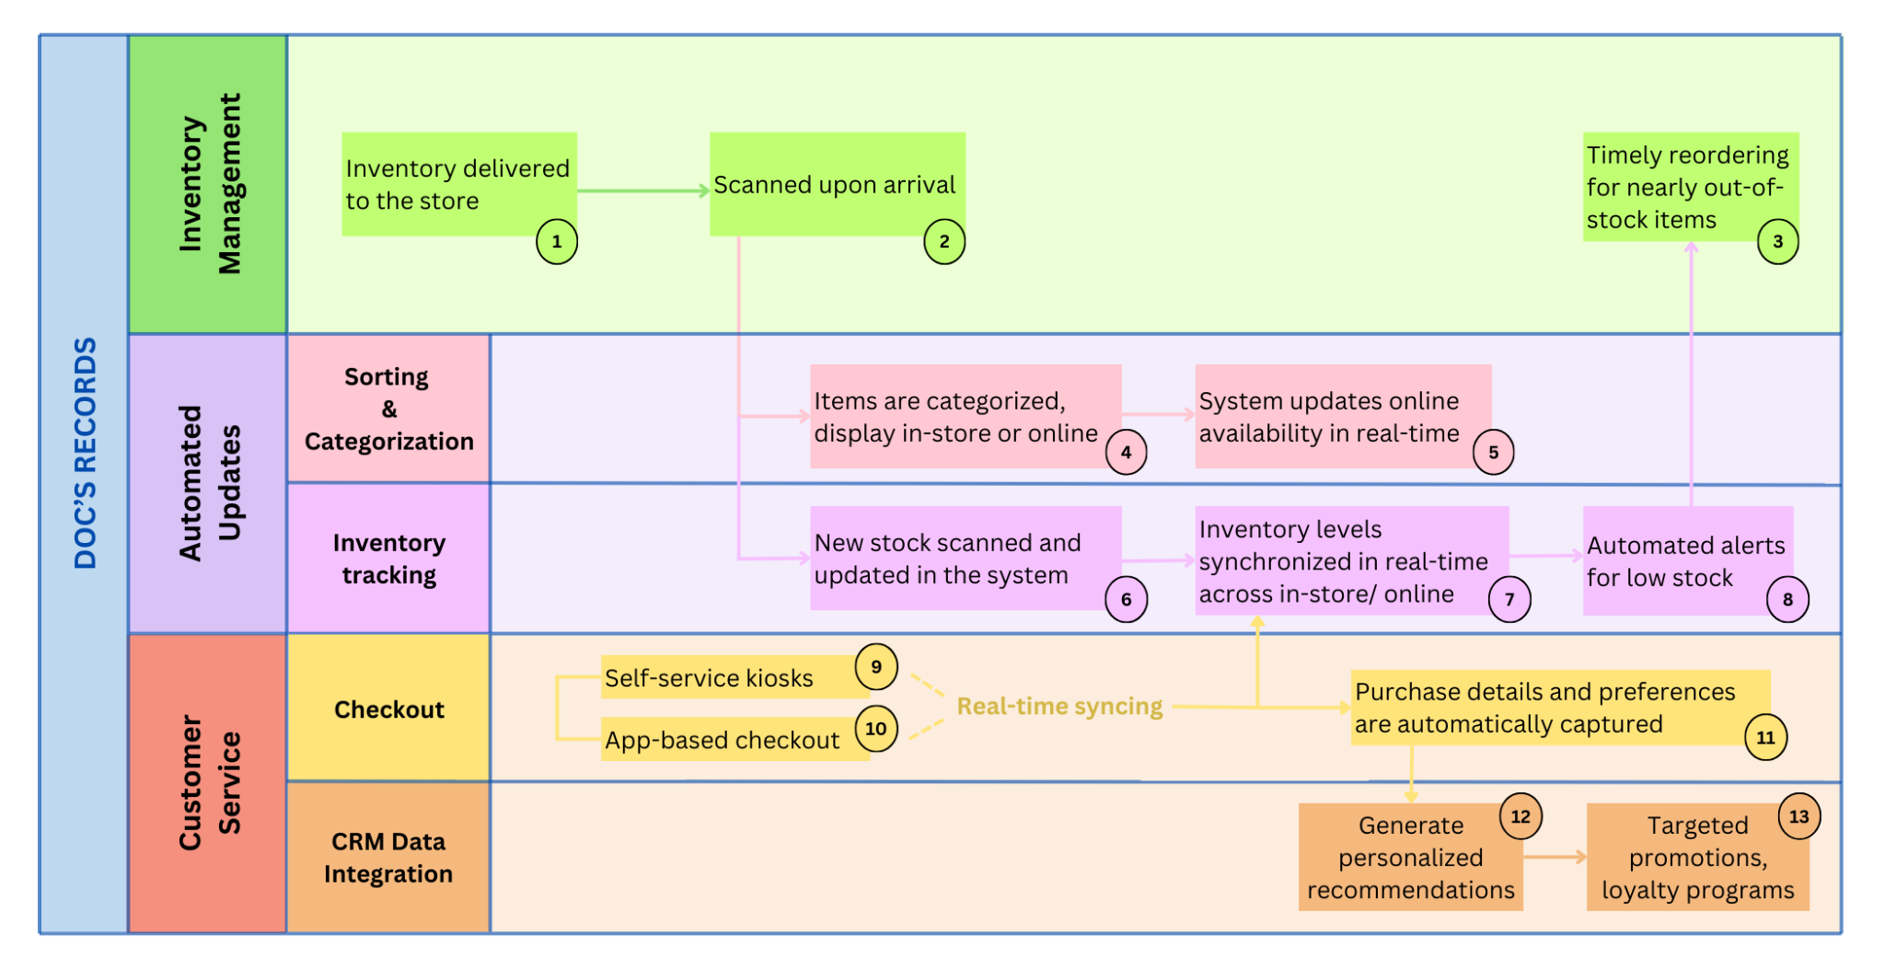
Explanation of how BPM highlighted key improvements:
Box 2: When inventory is delivered to the store, it is immediately scanned. This helps eliminate the need for manual entry, reducing errors and speeding up the process. Accurate initial stock updates allow for immediate availability tracking.
Box 5: When items are categorized and displayed in-store or online, the automatic software system updates online availability in real-time.
Box 7: Automation from scanning helps synchronize inventory across online and physical stores. The reason why it is connected to the checkout section under Customer Service Lane is because, whenever customers make a purchase, new sales transactions automatically adjust inventory levels in real-time. Therefore, inconsistencies in manual inventory tracking can be significantly mitigated. Up-to-date inventory information supports better decision-making for managing stock and reduces manual intervention, leading to faster service.
Box 8: Automated inventory tracking also includes automated alerts for low stock. This helps with ABC Vintage Store inventory management (closely associated with Box 3). Also ensures high-demand products remain available, reducing missed sales opportunities.
Box 9 and 10: The addition of self-service kiosks or app-based checkout options reduces bottlenecks at the checkout counter by allowing multiple customers to complete transactions simultaneously. It also provides real-time syncing of inventory levels with the system, ensuring stock levels are accurate post-purchase and reducing customer wait times.
Box 11: From self-service kiosks and app-based checkout instead of manual logging, purchase details and preferences can be automatically captured. This enables personalized marketing, targeted promotions, and better customer insights, driving loyalty and repeat business (Box 12 and 13).
Overall, the swimlane model shows separate lanes for inventory management, customer service, and automated updates, emphasizing the reduction in manual work and illustrating how automation and self-service improve customer flow.

Estimated Capacity Increase
With these process improvements, the expected capacity for serving customers could increase by an estimated 10% per hour. This estimate is based on reducing bottlenecks at critical points in the customer experience, such as inventory lookups and checkout wait times. For instance, introducing real-time inventory tracking can reduce employees' time searching for products, which accounts for approximately 10% of their workload during peak periods. Additionally, self-service options can streamline checkout processes, enabling quicker transactions and reducing lines. By automating tasks like inventory management and checkout, ABC Vintage Store can reallocate employee efforts toward personalized service, improving overall efficiency. These improvements collectively streamline operations and are projected to serve an additional 3-4 customers per hour on average, aligning with the 10% increase in capacity. The combination of self-service and real-time inventory tracking enhances customer satisfaction and reduces employee workload, allowing staff to focus on assisting customers with more complex needs. This improved efficiency positions ABC Vintage Store for long-term success while providing a better shopping experience.

Conclusion
The recommended process improvements for ABC Vintage Store focus on streamlining manual tasks, automating inventory updates, and empowering customers to complete their checkouts. By addressing bottlenecks and adopting an automated approach, ABC Vintage Store can increase its operational capacity, enhance service efficiency, and provide customers with a more satisfying shopping experience. The To-Be Business Process Model visually supports these improvements, showcasing the potential for greater throughput, faster inventory updates, and an overall smoother workflow.

Development Strategy
Software Selection
 | Vend | Square
Industry | Retail | Retail
Size of Business | Small to Medium | Any
Price | - around $119 monthly for retail and online POS  - Vend is compatible with current systems so unless new registers are needed, there is not a hardware cost | - around $89 monthly for retail POS and 2.9% + 30 cents for each online purchase, fixed cost of $170 for the hardware if not using current compatible system, and variable costs of a few cents per transaction
Platform | - 1 to manage inventory, sales, customer information, employee performance  - Can unite online and physical store’s information | - 1 platform that can have QuickBooks and other tools integrated into the POS system  - can set up a Square Online website or integrate into the existing website
Inventory Tracking | - Can track SKUs to prevent stockouts and overstocking  - Can add promotions/discounts in advance | - Receive notifications when items are almost out of stock  - Use barcode scanner to update stock counts  - Offer in store pickups and shipping of products
Real-Time Insights | - Real-time insights into sales, inventory, customer preferences, and team performance | - Information on customer’s preferences, spending habits, and contact information  - Create work schedules  - Sales and profit reports
Payment Process | - Automated payment process  - Payment process is embedded in POS system  - Easy to access reports from POS | - Accepts any major payment method for a quick payment process  - Customers can pay themselves without employee intervention at self-service kiosks
Overall Pros | - Updated inventory across physical and online stores, real time analytics, improves customer service, compatible with current system | - Includes an online store that syncs with in store sales  - Accepts various payment types  - Implements CRM and other tools for no extra cost  - Strong marketing techniques  - Self-service kiosks
Overall Cons | - Subscription fees can be costly for small businesses  - Some POS reports are less in depth than other software  - Cloud based system so could run into issues if there is poor network  - Self-service kiosks are not as easily implemented for retail purposes | - Square charges a small fee for every transaction that can add up (ABC Vintage Store will have a manageable number of transactions because they are a smaller, local business)  - Slow customer support (business should not need an increased amount of support because of good functionality)  - Customized reports and interface may be limited (ABC Vintage Store will not need a highly advanced interface due to not dealing with numerous stores/inventory)

Software Evaluation
Criteria | Relative  Weighted  Importance | Software 1: Vend | Score: 1-5 (highest) | Weighted Score | Software 2: Square | Score: 1-5 (highest) | Weighted Score
Real-Time Insights
Real Time Inventory Tracking | 20 | Levels of inventory are updated immediately after sales are made and new items are inputted into the system | 5 | 100 | Inventory is updated immediately after a change occurs across the physical store and online store levels | 5 | 100
Website Visibility | 20 | Physical store and online store can sync inventory data, basic features | 4 | 80 | Counts of inventory are automatically updated online and in store, more advanced features with SEO and website customization | 5 | 100
Customer Organization Issues
CRM Software for Business Data | 15 | Business has data on customer preferences and purchase history, no SMS marketing, and more basic customer feedback options | 4 | 60 | Business can track customer details and transaction history, SMS marketing to customers and post purchase/experience surveys | 5 | 75
CRM Engagement with Customer | 5 | Business can send customers promotions and product recommendations based on their purchase history | 3 | 15 | Business can send customers targeted communication including birthday offers, promotions, and thank you emails | 5 | 25
Software Accessibility
Employee Data Entry in Software | 15 | User friendly interface designed to reduce employee training time and manual errors | 4 | 60 | Simple interface that allows employees to scan barcodes or manually enter item details into the POS system | 5 | 75
Economic Issues
Cost of Software (Monthly Subscription) | 25 | Around $119 / month with online and physical store integration; extra costs depending on hardware purchased (tablets, scanners, etc.). Vend can be compatible with the current system, but not as wide as Square. | 3 | 75 | Around $89 / month subscription with 2.5% + 30 cents per purchase in store and 2.9% + 30 cents per purchase online. Extra costs depending on hardware purchased (tablets, scanners, etc.) Square can be compatible with the current system. | 5 | 125
Total | 100 | - | - | 390 | - | - | 500

The cloud-based software Square appears to be the best choice for ABC Vintage Store to implement into their business. After evaluating the software matrix created and what is important in the implementation of the new technology, Vend by Lightspace received a score of 390 and Square received a score of 500. Square would be a better option largely because of its simple and easy implementation into current systems of a business, marketing techniques with customers like thank you emails and promotions based on customer purchase history, and customer relationship management with detailed information that is helpful to the business.
The monthly subscription for Square is at a lower cost than Vend’s offering. While there are transaction fees for Square’s software, they will be minimal in relation to the number of products they sell. Square’s interactions with customers are more efficient than Vend’s offerings. Square allows for SMS messaging to customers with current promotions, marketing texts, post purchase surveys, and more. Square has a Self-Service Kiosk solution so that customers can speed up the checking out process and allow for employees to complete other tasks around the store. Also, with Square, businesses can implement better Search Engine Optimization into their website and have improved website customization.
While Vend has some of these offerings to a certain extent, Square offers more specialized and necessary cloud-based solutions to ABC Vintage Store. Vend could help ABC Vintage Store in an impactful way; however, if ABC Vintage Store decides to take the leap into purchasing new software, they should go with the more beneficial option, Square.

Feasibility Analysis
Economic Analysis
Tangible and Intangible Benefits
The tangible benefits include:
- Reduced time spent on manual inventory updates.
- Increased operational efficiency due to automation.
- Higher sales from real-time inventory tracking, leading to fewer missed sales opportunities.
- Reduced labor costs since manual tasks like inventory tracking and checkout are streamlined.
- Increased customer sales due to better service and personalized recommendations.
Intangible benefits:
- Enhanced customer experience and satisfaction from improved stock visibility and CRM features.
- Improved website that enhances the company’s image.
- Real-time inventory tracking system that supplies better information for marketing decisions.
Tangible and Intangible Costs
The tangible costs include:
- Initial implementation costs, such as software subscriptions from Vend or Square.
- Training costs for employees to learn and adopt the new systems.
- Maintenance costs for the software.
Intangible costs:
- Employee morale, potential resistance to change from employees that have been used to the old system.
- Risk of disruptions during the transition to the new systems, impacting short-term operations.
In order to mitigate these potential costs and risks, we will aim to provide a clear timeline and training plan to ensure smooth implementation. We will not apply the changes instantly but first conduct pilot testing to identify and minimize any disruptions before full deployment. Once the system is in place, we will offer ongoing support and regular updates to adapt to any technical, economic, and operational challenges that arise.
Technical Analysis
Technical Risks
- The first risk that we think of is compatibility and re-integration: The new inventory tracking and CRM systems may face compatibility challenges with existing systems or databases. This could result in data transfer delays or system conflicts.
- System downtime: During the data transition to the new system, there may be periods of downtime, potentially disrupting operations and customer service.
- Cloud-based solutions also come with data security risks, in particular data breaches and unauthorized access.
- System scalability: If the system is not configured to handle future growth in inventory or customer data, it could lead to performance bottlenecks.
- Resistance: Employees may also resist using the new system due to unfamiliarity, which could impact on the overall effectiveness of the implementation.
Impact on Technical Environment
This new information system will have both positive and negative impacts on the organization’s existing technical environments. Some negative impacts (risks) can be identified as above.
We want to add 2 more possible impacts:
- Infrastructure demands may increase. Existing hardware may need to be replaced or supplemented with new devices like barcode scanners, tablets, and kiosks. Unlike traditional systems, these advanced solutions may involve more complex maintenance procedures, which could require additional technical expertise.
- Moving to a cloud-based system introduces a new reliance on stable internet connectivity.
Regardless of these new demands, we believe that the most significant, positive impact lies in the ability to automate inventory updates and CRM data entry. As we have said earlier, it will come with various tangible and intangible benefits, such as reducing manual tasks, improving accuracy, and enhancing data visibility across the organization.
Mitigation of risks
All in all, when it comes to mitigation of all the aforementioned risks, we are committed to a comprehensive and proactive approach to ensure the successful operation of the new system. As already proposed above, this will begin with thorough pilot testing to identify and address potential issues before full deployment. When it comes to safeguarding inventory and customer data, we will apply encryption protocols and conduct regular security audits to minimize any risk of breaches. During implementation, we will also assess current hardware capabilities and upgrade equipment as needed to support the new system’s demands. Recognizing the importance of connectivity for a cloud-based system to perform consistently, we will work to make sure that reliable internet service is always in place, preventing disruptions to the best of our ability.
We understand that new technology may come with resistance. Therefore, employees will be provided with extensive training sessions and user guides to facilitate the transition and build confidence in using the system. To maintain long-term success, we will offer ongoing technical support to address any concerns in a timely manner, as well as evaluating system performance regularly to maintain its scalability. Throughout the process, we will be open to any feedback from employees and stakeholders, ensuring that adjustments can be made promptly to optimize the system and match the needs of any involved parties. This way, we believe that we can maximize our proposal’s value to the organization.
Operational Analysis
The system that has been proposed to improve ABC Vintage Store will solve the business challenges that they are facing. Since they are struggling to consistently update their website with items that are part of the “Vintage Stock” collection and items that are listed as “in stock” but actually out of stock, the solution of a cloud-based software will address this problem. The software Square immediately updates inventory counts once items are scanned in and out of the store whether it be online or instore. To keep up to date with “Vintage Stock,” an employee will need to input the inventory in the system at first by scanning the items’ barcodes, but after that initial input, the system will automatically update the inventory levels when items are scanned. To speed up check out processes, self-checkout kiosks in iPad form will be implemented into the physical store. This will allow employees to work on other important tasks around the store.
The software will also enable ABC Vintage Store to collect and retain customer information like purchase history, birthday, feedback, and more. This type of information will help when sending promotional emails and marketing emails to customers with the aim of increasing sales and store visibility. Employees can leverage customer information with purchase history and preferences to make recommendations on products either in-store or by sending targeted emails about items in stock. If customers would like a purchase that is currently out of stock, they can opt in to receive communication about when that item will become available.
To improve customer satisfaction within the online website, the shopping and purchasing experience will go more smoothly and efficiently. The interface for the online website can be improved per Square’s solutions to make the online shopping experience easier. The customer will not have to search extensively throughout the website to find a certain item. They will be able to browse quickly by filtering the products by genre, year, album, and more. With the software, the customer can also choose to pick up their items in store rather than paying for a shipping fee.
The current bottleneck that has been addressed with our proposed updates to ABC Vintage Store is the time that it takes employees to manually input, track, and manage inventory. These tasks take away employees from completing other important jobs around the store, and it decreases the time that employees and customers can have positive in-store interactions. After addressing ABC Vintage Store’s current bottleneck, which we mainly identify as manual inventory updates, we expect a new bottleneck related to the delays of potential time waiting to receive out of stock products back to the store. With improved website visibility and technological updates in-store, making purchasing and shopping processes simpler for the customer, we believe that ABC Vintage Store will face trouble in keeping popular products in stock. When customers purchase all of ABC Vintage Store stock in a certain product, they will need to reorder those items from the supplier, causing delays in receiving and restocking the product. This will now be the new bottleneck. In an attempt to mitigate this issue, the new software proposed, Square, will alert employees when an item is nearing a stock out level. When the system alerts the employees, employees can initiate the reorder process.
We strongly believe that the proposed system will give ABC Vintage Store valuable opportunities to grow its business and retain customers. The store already has a growing popularity around Fort Worth downtown with its passion for collecting vintage stock, so an automated inventory approach can only further capitalize on this niche market. By facilitating the real-time visibility of vintage stock both in-store and online, the software allows the business to quickly pinpoint fast-moving vintage items and replenish similar stock proactively, ensuring sustained customer interest in its specialized offerings.
Moreover, ABC Vintage Store has had its success partly because of the welcoming atmosphere that the physical store gives to its customers. The proposed system takes advantage of this by strengthening the in-store experience with self-service while also bringing the same easy access and welcoming usability to the online store. The enhanced online inventory tracking and website integration should make it easier for customers to shop anywhere, especially in the comfort of their own homes. This way, we anticipate that ABC Vintage Store will appeal to a much broader experience, including independent musicians, collectors, and casual buyers that would prefer not visiting the physical store. Our CRM system will also bring about more customized customer engagement, making them feel more valued and place increased trust in ABC Vintage Store. With target recommendations and promotions based on purchase history in place, customer loyalty will be greatly enhanced whether it’s online or offline. Therefore, our proposed approach will help blend the existing charm of ABC Vintage’s physical store with a modern, personalized online experience and automated inventory tracking: From this, ABC Vintage Store can strengthen its unique identity while building lasting relationships with its customers.
Organizational Impact
The proposed system aims to enhance data accuracy, customer satisfaction, and organizational efficiency. With automated inventory updates minimizing manual efforts, inventory management will operate more efficiently, allowing employees to focus on customer service and strategic planning. By introducing self-service kiosks and app-based checkouts, customers can enjoy a faster, more convenient experience, ultimately boosting their satisfaction. This shift emphasizes a customer-focused culture, where employees can engage directly with clients, enhancing service quality. Furthermore, CRM data integration will automatically capture customer purchase details, providing valuable insights into preferences that support targeted marketing and loyalty initiatives.
The suggested system will significantly impact the organization's current operational, cultural, and organizational procedures. Organizationally, the move to self-service and automated choices will increase productivity, decrease manual labor, and free up staff members to concentrate on higher-level duties and customer service. These adjustments will promote a customer-centric mentality and an atmosphere emphasizing ongoing learning and adaptability by encouraging employees to adjust to new technology on a cultural level. Operationally, automation will significantly lessen the need for human inventory and data management processes, enabling uniform, effective departmental operations. By focusing on uniformity, this modification will reduce variability in data handling and customer service interactions, guaranteeing a smooth, consistent experience for both clients and staff. These effects show how an organization is moving toward becoming more technologically advanced, effective, and focused on operational excellence.

Implementation Plan
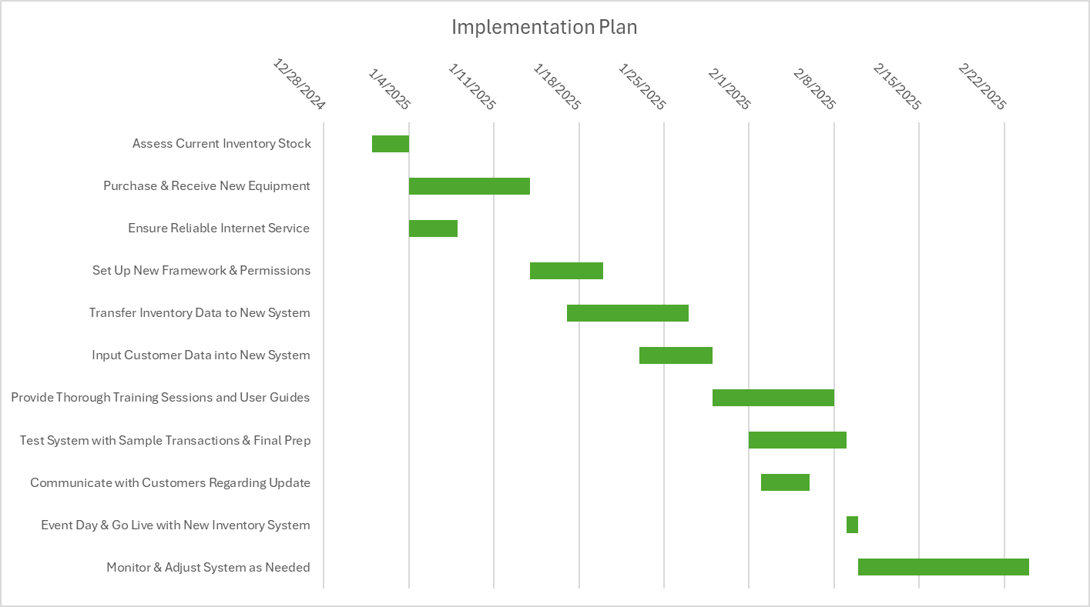

References
Arunesh, G. (2011). Systems analysis and design. PHI Learning Pvt. Ltd.
OpenAI. (2024). ChatGPT (Nov 19 version) [Large language model]. https://chat.openai.com/chat
Retail POS System - Retail Point of Sale Software | Square. (2024). Square. https://squareup.com/us/en/point-of-sale/retail#panel-sell everywhere53qayTfhr7iYveJzqcmVPB
Stratvert, K. (2023, July 28). How to Make Gantt Chart in Excel. Youtube. https://www.youtube.com/watch?v=zC22yPmc6Kw
Vend is now Lightspeed. (n.d.). Lightspeed. https://www.lightspeedhq.com/vend/

Lessons Learned
Throughout this project, our group has gained valuable insights into the importance of cooperation and clear communication for achieving success. We quickly realized that coordinating our individual efforts toward a common goal was essential, especially when gathering requirements. Each team member brought unique perspectives that enhanced our discussions and helped us engage effectively with potential stakeholders. This collaborative effort allowed us to develop a deeper understanding of the system's needs. To balance user expectations with business objectives, we employed techniques such as creating user personas and crafting user stories. These strategies clarified our focus on the end users and ultimately enabled us to design a more effective solution that met both user needs and business goals.
As we progressed, we identified significant operational inefficiencies, including outdated, staff-dependent checkout procedures and manual inventory tracking systems. Our team recognized these as major bottlenecks that impeded productivity and user experience. To address these challenges, we explored various solutions, such as implementing self-service kiosks and automated inventory management. This exploration underscored the importance of many group discussions and collaborative decision-making in effectively identifying and resolving issues.
Another critical lesson we learned was the need for a systematic approach to evaluating technological solutions. By comparing different software options, such as Vend and Square, we developed a framework for assessing usability, pricing, and functionality in alignment with our business requirements. This process highlighted the importance of making informed decisions using data and insights.
We also anticipated potential obstacles that could arise during implementation, such as possible staff resistance to adopting new systems and potential disruptions during the transition period. To address these challenges, we engaged in discussions about feasible strategies, such as offering comprehensive training sessions for staff and implementing the system in phases. This collaborative problem-solving approach not only addressed potential issues but also strengthened our mutual trust as a team.
Furthermore, we maintained a strong focus on enhancing customer experience throughout the project. By integrating components like CRM systems and real-time inventory updates, we reinforced the significance of prioritizing end-user satisfaction. Our team concluded that aligning technological solutions with customer needs not only boosts satisfaction for the customer and employee but also contributes to the long-term success of the organization. In summary, this project provided us with invaluable experience in problem-solving, collaboration, and strategic thinking. Together, we tackled operational issues, developed innovative solutions, and gained a deeper understanding of the importance of teamwork. Additionally, we learned of the importance of beginning the project early to allow time for team discussion, problem solving, and trial and error. These experiences will undoubtedly influence how we approach future projects, emphasizing the necessity of open communication, shared objectives, and a customer-first mindset.

